iglidur X: Plain bearing material withstands temperatures from -100 to + 250°C

For use in extreme heat, cold or acid: Now available in even more sizes

The motion plastics specialist igus have been offering a material for the extremes for many years - iglidur X. Pressure, heat, cold, moisture or acids - nothing makes iglidur X give way. As part of the igus standard range campaign that covers 113 dimensions, more are being added to the existing 312 catalogue dimensions. All standard sizes of the plain bearing material are thus available from igus within 24 hours.

iglidur X is the perfect material for applications that can be really hot, cold or harsh. iglidur has been designed by igus for extremely difficult environments. These include extreme operating temperatures from -100 to +250°C, even in continuous operation and with aggressive chemicals.

iglidur X provides a significantly longer life in practice
The chemical resistance of iglidur X makes it ideal for use in, inter alia, fuel pumps. Traditionally other plain bearings such as PTFE-coated bearings have at times contaminated the fuel and damaged the shafts. Now the iglidur X bearing ensures a longer service life of the pump. One of the most extraordinary areas of application of iglidur X was in the "Porton Man", a robot used for testing protective clothing in the British defence industry. This was among the submissions for the 2015 manus competition for exciting bearings applications. The rugged iglidur X bearings that withstand the stress of chemical, biological or radioactive materials are applied in all joints of the robot being used for testing the protective clothing.

Caption:


Picture PM2715-1
Pressure, heat, cold, moisture or acids - nothing makes iglidur X give way. (Source: igus GmbH)

Video caption:

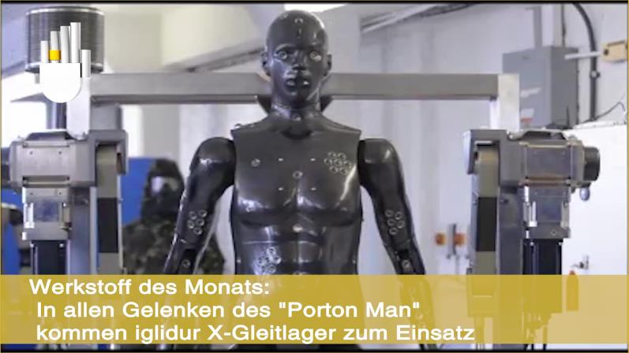
Video PM2715-1
Plain bearings made of iglidur X appear immune to the most powerful stresses. The iglidur X bearings are used in all the joints of the "Porton Man". (Source: igus GmbH).

https://youtu.be/RwKOTmEao2w

PRESS CONTACT:  Oliver Cyrus  Head of Media and Advertising  igus® GmbH  Spicher Strasse 1a  51147 Cologne  Tel. 0 22 03 / 96 49-459  Fax +49 22 03 / 96 49-631  ocyrus@igus.de  www.igus.de/de/presse | ABOUT IGUS:  igus GmbH is a globally leading manufacturer of energy chain systems and polymer plain bearings. The Cologne-based family business has offices in 36 countries and employs around 2,700 people around the world. In 2014, igus generated a turnover of 469 million euros with motion plastics, plastic components for moving applications. igus operates the largest test laboratories and factories in its sector to offer customers quick turnaround times on innovative products and solutions tailored to their needs.

The terms ‘igus, e-ketten, e-kettensysteme, chainflex, readycable, easychain, e-chain, e-chainsystems, energy chain, energy chain system, flizz, readychain, robolink, pikchain, triflex, twisterchain, invis, drylin, iglidur, igubal, xiros, xirodur, plastics for longer life, CFRIP, dryspin, manus and vector’ are protected by trademark laws in the Federal Republic of Germany and internationally, where applicable.

