Clean winner: igus e-skin receives Fraunhofer clean technology award
2nd prize of the "Clean! 2018" award for the e-skin modular corrugated tube with ISO Class 1

igus has developed the e-skin for the energy supply sector in clean production areas. It provides systems with data, media and energy without generating airborne particles through friction above the strict limit, which could contaminate the room. The improved corrugated hose for cleanroom applications received the 2nd prize in the Fraunhofer clean technology award, which was presented on 6 February 2018.

The production of microchips, flat screens, implants, pharmaceutical products or micro- and nano-products would be inconceivable without a clean, pure or high-purity manufacturing environment. Any contamination has a direct negative impact on products and processes and costs a lot of money to the manufacturer. The motion plastics specialist igus has developed a novel corrugated tube for energy supply in clean rooms: the e-skin. It has the seal of approval Fraunhofer Tested Device of the ISO class 1 and received now the 2nd prize of the Fraunhofer clean technology award "Clean! 2018". Here, outstanding ideas in the field of clean technology are rewarded; not only ideas that are completely new, but also those that increase the economic efficiency of production processes.

Enclosed type with abrasion resistance for clean production
The e-skin is made of tribologically optimised, abrasion-resistant plastic. The separable upper and lower shells can be easily put together by a "zipper" to a fully enclosed tube, which is highly dust-proof and water-resistant. This guarantees both cleanroom compatibility and a quick filling and maintenance of the cables. The assembly-friendly e-skin is also extremely light and ideal for small installation spaces, for instance in pick & place applications, and unlike other corrugated hoses, it is even applicable for short unsupported distances due to the stiffness of the material, the rib profile and a defined direction of motion. The design and material of the e-skin have been tested for cleanroom compatibility in the in-house igus test laboratory.

Image captions:

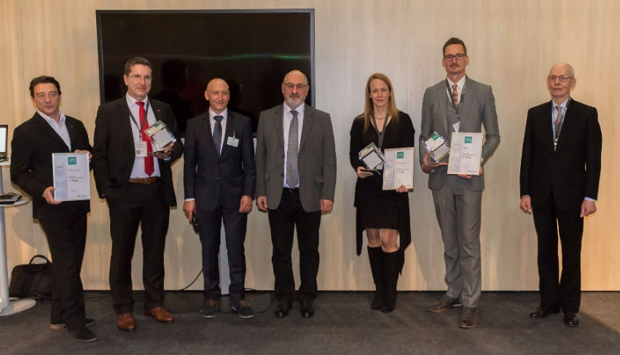
Picture PM0718-1
The e-skin received the 2nd prize of the Fraunhofer "Clean! 2018" clean technology award. Philipp Hagedorn (2nd from right.), e-chains product manager at igus, received the award (source: igus GmbH).

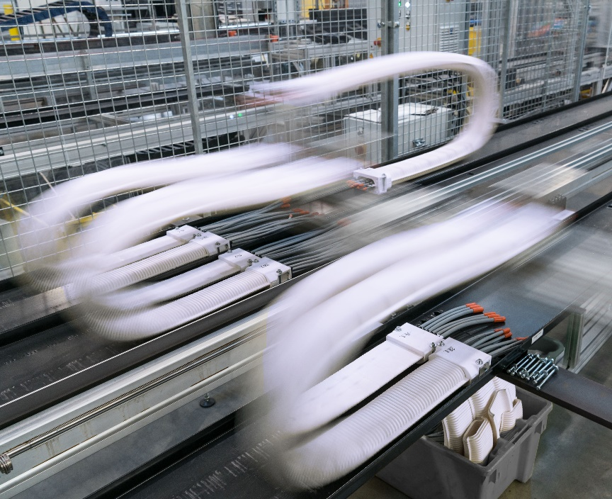
Picture PM0718-2
The e-skin: developed for cleanroom applications, tested under real conditions for 6.4 million double strokes at 3 m/s in the laboratory (source: igus GmbH).

PRESS CONTACT:  Harish Bhooshanan  Product Manager  E-ChainSystems®  igus (India) Private Limited  36/1, Sy. No. 17/3  Euro School Road,  Dodda Nekkundi Industrial Area - 2nd Stage  Mahadevapura Post  Bangalore - 560048  Phone : +91-80-49127809 (Direct)  Harish@igus.in  Visit us on www.igus.in | ABOUT IGUS:  igus GmbH is a globally leading manufacturer of energy chain systems and polymer plain bearings. The Cologne-based family business has offices in 35 countries and employs around 3,800 people around the world. In 2017, igus generated a turnover of 690 million euros with motion plastics, plastic components for moving applications. igus operates the largest test laboratories and factories in its sector to offer customers quick turnaround times on innovative products and solutions tailored to their needs.

The terms "igus", "chainflex", "CFRIP", "conprotect", "CTD", "drylin", "dry-tech", "dryspin", "easy chain", "e-chain", "e-chain-systems", "e-ketten", "e-kettensysteme", "e-skin", "flizz", "iglide", "iglidur", "igubal", "manus", "motion plastics", "pikchain", "readychain", "readycable", "speedigus", "triflex", "plastics for longer life", "robolink", and "xiros" are protected by trademark laws in the Federal Republic of Germany and internationally, where applicable.

